**1 ORGANISATION OF SYSTEM  
  
2 DESCRIPTION OF System  
  
3 fIXING TO THE MASONRY**3.1 Anchor bolts  
3.2 Steel brackets  
3.3 Sub-frame section  
3.4 Fasteners, fixing to site  
  
**4 SURFACE TREATMENT**4.1 Coating elements made of pre-treated steel profiles  
4.2 Coating elements made of bright steel profiles  
  
**5 DOOR FITTINGS**5.1 T30-1 Single-leafed doors (Janisol 2)  
5.2 T30-2 Double-leafed doors (Janisol 2)  
  
**6 Glazing  
  
7 panels**  
**8 INSTALLING INFILL PANELS**8.1 Installing F30 glass or infill panel with dry glazing  
8.2 Installing F30 glass or infill panel with ceramic fibre strip  
8.3 Installing F30 glass with glazing bead on both sides and dry glazing  
8.4 Installing F30 glass and/or infill panel with glazing bead on both sides and ceramic fibre strip  
 **9 SHEET STEEL PARTS  
  
10 SealANTS  
  
11 ALTERNATIVE OFFERS**11.1 Offers  
11.2 Validity  
  
**1 ORGANISATION OF SYSTEM**

**Scope of application:**

1. for single and double-leafed door sets
2. for single and double-leafed doors in glazed walls
3. for fixed lights / glazed walls

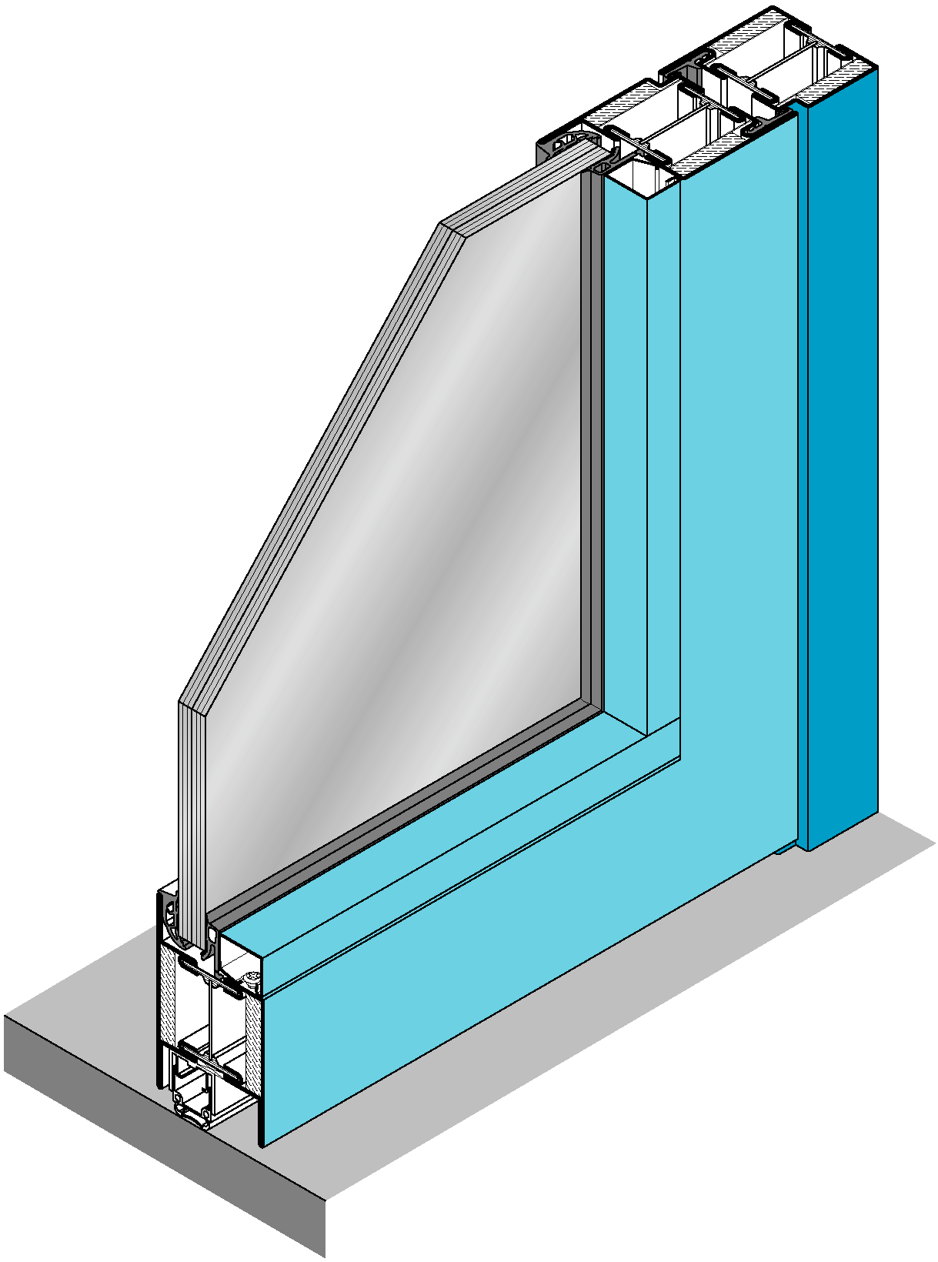

**2 DESCRIPTION OF System**

Flush system of profiled sections made from Jansen steel profiles for single- and double-leafed doors, doors in glazed walls and fixed lights or glazed walls.

Installed height 60 mm, structural width of door leaf section also 50 mm. Profiles of varying widths 25 mm and 50 mm can be used for frame, mullion and transom and for various subdivisions.

Elements manufactured by welding, visible welds neatly ground down and trimmed.

Widened frame, transom and lintel details must be constructed using combinations of profiles together with sheet metal inserts welded-in flush with the surface.

All door leaves have double rebate seals in flame retardant quality. Seals at base level according to the threshold construction selected.  
  
  
 without sills, without sealing  
 without sills, with hollow aluminium semi-circular profile and threshold gasket   
 without sills, with automatic drop seal  
 with sill rebate (take account of difference between sill and floor)   
  
Only systems tested by EMPA and approved by the VKF may be used.

**Profiles selected for door frames:  
  
Frame left-hand side** Profile no. Profile width mm  
  
**Frame top** Profile no.  Profile width mm  
  
**Frame right-hand side**  
  
 Profile no.  Profile width mm  
  
**Base / threshold**   
  
 Profile no.  Profile width mm  
 steel tube  Measurement mm  
  
**Mullion**  
  
 Profile no.  Profile width mm  
  
  
**Transom**  
  
 Profile no.  Profile width mm  
  
**Glazing bead**  
  
 Profile no.  Measurement mm

**Profiles selected: Door leaf**  
  
**Frame, hinge-side**  
  
 Profile no.  Profile width mm  
  
**Frame, top**  
  
 Profile no.  Profile width mm  
  
**Frame. lock-side**   
  
 Profile no.  Profile width mm  
  
**Frame, meeting stile**  
  
 Profile no.  Profile width mm  
 Profile no.  Profile width mm  
  
**Frame bottom/ base rail**   
  
 Profile no.  Profile width mm  
  
**Glazing bar/transom**  
  
 Profile no.  Profile width mm  
  
**Glazing bead**  
  
 Profile no.  Measurement mm  
  
Please refer to the manufacturer's documentation for additional information and notes concerning fire-proof technical authorisations, construction, fabrication, installation of fittings and assembly.

**3 FIXING TO THE MASONRY**

*3.1 Anchor bolts (Fire-proofing DIN 4102)*

Fix the door and/or wall elements with anchor bolts that have been tested and approved by the construction supervising authority. Use stainless steel fixing plates and spacers made of Fermacell or equivalent in the vicinity of the bolts. Plug the gap between frame and masonry tightly with mineral wool (min. raw density 120 kg/m³).

Seal the joints (approx. 10 mm wide) at connections with fair-faced concrete or facing masonry with silicone.

*3.2 Steel brackets*

Mount the door and/or wall elements using steel brackets welded on-site and placed under the rendering. These brackets should be fixed to the masonry by bolts approved by the construction supervising authority. Plug the gap between frame and masonry tightly with mineral wool (min. raw weight 120 kg/m3).

*3.3 Sub-frame sections*

Mount the door and/or wall elements on previously assembled sub-frame sections. Apply a Fermacell strip to these for insulation purposes. Fix the sub-frame sections to the masonry using approved anchor bolts.

*3.4 Fasteners, fixing to site*

Apply a good-quality anticorrosive to all fixing devices such as supporting brackets, fixing plates and steel sub-constructions.  
  
All fixing devices and fasteners such as screws, bolts etc. must be included in the unit prices.

**4 SURFACE TREATMENT**  
*4.1 Coating elements made of pre-treated steel profiles*

4.1.1 Manufacture of the elements from profiles made of hot-galvanised steel strips "Z"

Chromating or fine blasting, repairing welds with PUR zinc-dust primer, primer, top coat

Structure: Minimum thickness of coat *:  
Corrosion prevention:  
hot-dipped galvanised steel bars 20 µm  
  
Pretreatment:  
chromating according to DIN50 941  
or fine blasting  
  
Paint system:  
primer 20 µm  
top coat 30 µm  
  
Total structure: 70 µm  
  
Colour: RAL   
 NCS   
Pay particular attention to the special instructions of the system manufacturer concerning the surface treatment of Janisol 2 profiles.

4.1.2 Manufacture of the elements from profiles made of hot-galvanised steel strips "Z"

Chromating or fine blasting, repairing welds with suitable primer, primer, top coat with powder-coating  
   
Structure: Minimum thickness of coat *:  
Corrosion prevention:  
hot-dipped galvanised steel bars 20 µm  
  
Pretreatment:  
chromating according to DIN50 941  
or fine blasting  
  
Paint system:  
PES powder coating 50 µm  
  
Total structure: 70 µm  
  
Colour: RAL   
 NCS   
  
Pay particular attention to the special instructions of the system manufacturer concerning the surface treatment of Janisol 2 profiles.

4.1.3 Manufacture of the elements using      

Structure: Minimum thickness of coat *:  
  
Corrosion prevention:  
  
             
  
Pretreatment:  
  
             
  
Paint system:  
  
             
  
Total structure:        
  
Colour: RAL   
 NCS   
  
Pay particular attention to the special instructions of the system manufacturer concerning the surface treatment of Janisol 2 profiles.

*4.2 Coating elements made of bright JANISOL steel profiles*  
4.2.1 Manufacture of the elements from bright JANISOL steel profiles

Sand or shot blasting, zinc plating, top coat stove enamelled  
  
   
Structure: Minimum thickness of coat *:  
  
Pretreatment:  
sand or shot blasting A Sa 2 ½  
  
Corrosion prevention:  
zinc plating 40 µm  
  
Paint system:  
e.g. silicone-polyester 20 µm  
  
Total structure: 60 µm  
  
Colour: RAL   
 NCS Pay particular attention to the special instructions of the system manufacturer concerning the surface treatment of Janisol 2 profiles.

4.2.2 Manufacture of the elements from bright JANISOL-steel profiles

Sand or shot blasting, primed with reaction lacquer (2-component),  
top coat stove enamelled   
  
Structure: Minimum thickness of coat *:  
  
Pretreatment:  
sand or shot blasting A Sa 2 ½  
  
Corrosion prevention:  
reaction lacquer 40 µm  
  
Paint system:  
e.g. silicone-polyester 20 µm   
  
Total structure: 60 µm  
  
Colour: RAL   
 NCS        
  
Pay particular attention to the special instructions of the system manufacturer concerning the surface treatment of Janisol 2 profiles.

4.2.3 Manufacture of the elements from bright JANISOL steel tubes

Sand or shot blasting, primer and top coat with water-based paint  
  
Structure: Minimum thickness of coat *:  
  
Pretreatment:  
sand or shot blasting A Sa 2 ½  
  
Corrosion prevention:  
water-based acrylic resin 40 µm1)  
  
Top coat:  
water-based acrylic resin 30 µm2)  
  
Total structure: 70 µm  
  
Colour: RAL   
 NCS Pay particular attention to the special instructions of the system manufacturer concerning the surface treatment of Janisol 2 profiles.

4.2.4 Manufacture of the elements from      

Structure: Minimum thickness of coat *:  
  
Corrosion prevention:  
  
             
  
Paint system:  
  
             
  
Total structure:        
  
Colour: RAL   
 NCS Pay particular attention to the special instructions of the system manufacturer concerning the surface treatment of Janisol 2 profiles.

1) e.g. Alponit Korrodur  
 2) e.g. Alposeta

**Terms and Definitions** are taken from the SZFF/CSFF Standard 52.02 «Quality Specifications for Steel Coatings». Any discrepancies and/or additions are due to the fact that these specifications concern the "piece-wise coating of structures exposed to weather" exclusively.

1. In practice the average thickness of a coat corresponds to approximately twice the minimum thickness (apart from powder coating). Depending on the product, a wash primer (intermediate primer) may be required. In this case, the minimum thickness is increased by 20 µm.
2. The minimum thickness on a sandblasted or zinc-plated support refers to the coat measured over the tips.
3. For «dry interior» the average thickness of the coat may be considered equivalent to the minimum thickness indicated.

**5 DOOR FITTINGS***5.1 Single-leafed doors*

2 units  weld-on hinge 3D adjustable  
  weld-on hinge height adjustable  
  weld-on hinge  
  screw-on hinge height and sides adjustable  
1 set  door lever / pivot hinge (for floor spring)  
  
1 unit rebate bolt, centred  
  
1 unit  mortise lock (standard version)  
  mortise lock (panic version type B)  
  mortise lock (panic version type E)  
  mortise lock with additional bolt at the top  
 (standard version)  
  mortise lock with additional bolt at the top  
 (panic version type B)  
  mortise lock with additional bolt at the top  
 (panic version type E)  
  
1 unit  striking plate  
1 set  Electric door-opener  
  
1 set  stainless steel handle ref./type        
  aluminium handle with steel core, anodised EV1  
  grip handle, stainless steel, on one side only, ref./type        
  
1 set  overhead door closer type        
 make        
  
  floor spring type        
 make        
  
  concealed overhead door closer (Dorma ITS 96)  
 art.no      + slide rail art.no        
  
Cylinder type       and roses by the customer

All fittings, accessories and fixing screws etc. must be included in the unit prices..  
  
Only fittings that have been approved and tested with the system may be used.

*5.2 Double-leafed doors*

4 units  weld-on hinge 3D adjustable  
  weld-on hinge height adjustable  
  weld-on hinge  
  screw-on hinge height and sides adjustable  
2 sets  door lever / pivot hinge (for floor spring)  
  
1 unit rebate bolt, centred  
  
1 unit  mortise lock (standard version)  
  mortise lock (panic version type B)  
  mortise lock (panic version type E)  
  mortise lock with additional bolt at the top  
 (standard version)  
  mortise lock with additional bolt at the top  
 (panic version type B)  
  mortise lock with additional bolt at the top  
 (panic version type E)  
  
1 unit  striking plate  
1 set  electric door opener  
  
1 unit  espagnolette with bolt rod  
1 unit  mortise espagnolette with switch latch and bolt rod  
  
1 set  stainless steel handle ref./type        
  aluminium handle with steel core, anodised EV1  
  grip handle, stainless steel, on one side only, ref./type        
   
1 set  overhead door closer (for service leaf only)  
 type       make        
  
  floor spring (for service leaf only)  
 type       make        
  
  overhead door closer (for service leaf and fixed leaf), with- closing sequence regulator  
 type       make        
  
  floor spring (for service leaf and fixed leaf), with- closing sequence regulator. Note minimum width of leaf type       make        
  
  concealed overhead door closer (Dorma ITS 96) art.no       1 slide rail with closing sequence regulator art.no        
  
Cylinder-type       and roses by the customer

All fittings, accessories and fixing screws etc. must be included in the unit prices.  
  
Only fittings that have been approved and tested with the system may be used.

**6 glaZIng**  
*6.1 Fire-proof glass, fire resistance category F30 according to DIN4102*

**Choice of glass:** Swissflam type 30-N2 (thickness of glass 16 mm)  
 Pyrostop type 30-1 (thickness of glass 15 mm)  
 Promaglas 30 type 1, type 3, type5 (thickness of glass 17 mm)  
 Contraflam type 30-N2 (thickness of glass 16-22 mm)  
 Pyranova 30 S1 (thickness of glass 17 mm)  
  
Maximum size of glass according to authorisation and instructions of glass and/or system manufacturer.

*6.2 Fire-proof insulating glass fire resistance category F30 according to DIN4102*

**Choice of glass:** Swissflam type 30-N2 ISO (thickness of glass 26 mm)  
 Pyrostop type 30-2 / type 30-3 (thickness of glass 36 mm)  
 Pyrostop type 30-2 / type 30-3 (thickness of glass 32 mm)  
 Promaglas 30 type 3 (thickness of glass 35 mm)  
 Contraflam type 30-N2 ISO (thickness of glass 26-32 mm)  
  
Maximum size of glass according to authorisation and instructions of glass and/or system manufacturer.

**7 PanelS**  
  
*Metal infill panels F30 according to DIN4102*

Metal infill panel fire resistance categoryF30 according to DIN4102 for assembly in Janisol 2-frame construction, consisting of plaster-board slab and steel sheets glued onto both sides with silicone.  
  
**Panel structure:**  
  
outside: galvanised steel sheet /aluminium sheet 1 mm  
panel core: plaster-board slab or Promatect H 18 mm  
inside: galvanised steel sheet /aluminium sheet 1 mm  
  
Total thickness of panel: 20 mm

**8 INSTALLING INFILL PANELS**   
  
*8.1 Installing F30 glass or infill panel with dry glazing*

The glass is fixed in the frame construction with invisible steel glazing beads and mounted flush with the frame using special steel bead studs.  
  
Between the fire-proof glass and the flanges of the profile and/or glazing bead, insert flame-retardant glazing seals. For the glass project and the pads, follow the instructions of the glass supplier. The glazing bridges must be made of material that is compression-proof and non-inflammable (e.g. Fermacell, hardwood).  
  
Additional information and instructions concerning glazing, choice of seal etc. will be found in the appropriate documentation of the system manufacturer.  
  
The glazing, installation of the glass and all accessories required must be included in the unit price.

*8.2 Installing F30 glass and/or infill panel with ceramic fibre strip*

The glass is fixed in the frame construction with invisible steel glazing beads and mounted flush with the frame using special steel bead studs.

Between the fire-proof glass and/or panel and the glazing bead and/or flanges of the profile, apply self-adhesive ceramic fibre strips 20 mm wide (without sealing).

Between the fire-proof glass and/or panel and the glazing bead and/or flanges of the profile, apply self-adhesive ceramic fibre strips 17 mm wide. Seal the remaining joint cross-section with silicone as far as the top edge of the glazing bead..

For the glass project and the pads, follow the instructions of the glass supplier. The glazing bridges must be made of material that is compression-proof and non-inflammable (e.g. Fermacell, hardwood).  
  
Additional information and instructions concerning glazing etc. will be found in the appropriate documentation of the system manufacturer.  
  
The glazing, installation of the glass and all accessories required must be included in the unit price.

*8.3 Installing F30 glass with glazing bead on both sides and dry glazing*

The glass is fixed in the frame construction with invisible steel glazing beads and mounted flush with the frame using special steel bead studs.  
  
Between the fire-proof glass and the flanges of the profile and/or glazing bead, insert flame-retardant glazing seals. For the glass project and the pads, follow the instructions of the glass supplier. The glazing bridges must be made of material that is compression-proof and non-inflammable (e.g. Fermacell, hardwood).   
  
Additional information and instructions concerning glazing etc. will be found in the appropriate documentation of the system manufacturer.

The glazing, installation of the glass and all accessories required must be included in the unit price.

*8.4 Installing T30/F30 glass and/or infill panel with glazing bead on both sides and ceramic fibre strip*

The glass is fixed in the frame construction with invisible steel glazing beads and mounted flush with the frame using special steel bead studs.

Between the fire-proof glass and/or panel and the glazing bead, apply self-adhesive ceramic fibre strips 20 mm wide (without sealing). Does not apply to Pyrostop.

Between the fire-proof glass and/or panel and the glazing bead, apply self-adhesive ceramic fibre strips 17 mm wide. Seal the remaining joint cross-section with silicone as far as the top edge of the glazing bead..

For the glass project and the pads, follow the instructions of the glass supplier. The glazing bridges must be made of material that is compression-proof and non-inflammable (e.g. Fermacell, hardwood).  
  
Additional information and instructions concerning glazing etc. will be found in the appropriate documentation of the system manufacturer.  
  
The glazing, installation of the glass and all accessories required must be included in the unit price.

**9 SHEET STEEL PARTS**

Window sills, joint plates, end plates, and sheet steel cladding must be included in the unit prices including sub-construction, fastening plates, fire-proofing and the sealing materials required (in accordance with fire protection regulations).  
Pressed steel sections should generally be made of steel or hot galvanised sheet metal or equivalent. The sheet metal should be 1.5 - 2.0 mm thick, depending on the application.

**10 sealANTS**

Fixing details between the metal construction and the structure must be constructed in accordance with fire protection regulations and sealed using appropriate and approved sealing materials.  
  
All materials and stock used must be suited to the purpose and compatible with the adjacent materials and stock. The manufacturer's processing instructions must be followed.   
  
Unless specifically mentioned, all sealing and jointing jobs must be included in the unit prices.

**11 ALTERNATIVE OFFERS***11.1 Authorisation*

Alternative offers are authorised in combination with the model offer.

*11.2 Validity*

Alternative offers are only valid if the formal details are retained and the present technical conditions are met.   
  
In addition, the tenderer must enclose the appropriate authorisations concerning the requirements issued by the national bodies. (e.g. Swiss Fire Protection Certificate)

All the information contained in this documentation is given to the best of our knowledge and ability. However, we decline all responsibility for the use made of these suggestions and data.   
  
Compiled: August 2002